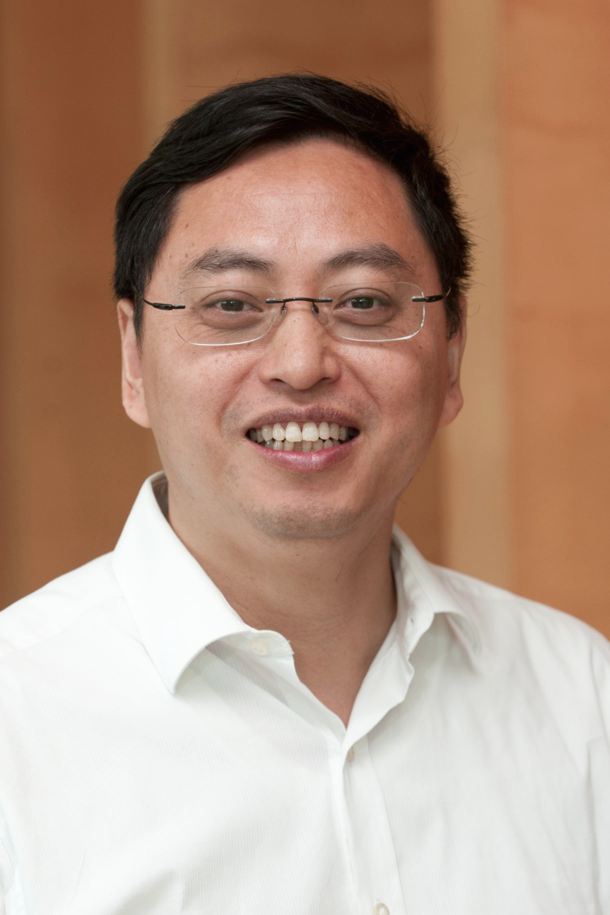
Dr. Wen Wang, 47, passed away on January 21, 2018 at the University of California San Francisco (UCSF) Medical Center, San Francisco after a year-long struggle against cancer. He is survived by his wife, Lei Zhang, son Darren, and daughter Aria, as well as his extended family in China.

Dr. Wang was a distinguished scholar in the field of public finance, specializing in intergovernmental fiscal relations, capital budgeting and finance, and education policy and finance. Dr. Wang received his bachelor’s degree from Nankai University, China, his Master of Public Administration from the University of Georgia, and his Ph.D. in Public Administration from the Maxwell School of Syracuse University. Before his departure, he was a tenured associate professor in the School of Public Affairs and Administration at Rutgers University-Newark. He had taught previously at the City University of Hong Kong and the School of Public and Environmental Affairs, Indiana University-Perdue University Indianapolis, University of South Carolina, and East Carolina University. He was also an Asia Fellow at the Mossavar-Rahmani Center for Business & Government, the Kennedy School of Government, Harvard University, and a fellow of the School of Public Policy at the University of Birmingham of Britain. Before coming to the U.S., he had worked at the Chinese Academy of Governance in Beijing.

Dr. Wang’s article on capital investment by school districts, which was published in the National Tax Journal, a top journal in his field, received the Richard A. Musgrave Prize for the best paper published in the journal in 2011. He was also the recipient of the Best Conference Manuscript Award by the Public Budgeting and Finance Section of the Western Social Science Association (WSSA) Conference in 2009. His research in several topical areas not only advanced the frontiers of public finance research but also provided practical insights for policymakers in state and local governments globally.

Dr. Wang was a founding member, former Treasurer, and long-time Board member of the China-America Association for Public Affairs (CAAPA). For his scholarly accomplishments, Dr. Wang was elected President of the Association in 2017-2018. He also served on the editorial board of the Journal of Public Budgeting, Accounting, and Financial Management. In addition, he had mentored many young scholars in the U.S. and China and was a beloved teacher. His scholarly impact and leadership were widely recognized, and his too-early departure from this world is indeed a great loss to the academic community.

The Board, members, and friends of CAAPA offer our deepest condolences to Dr. Wang’s wife and family. His scholarly example and his kindness and support for others will always be remembered.

